
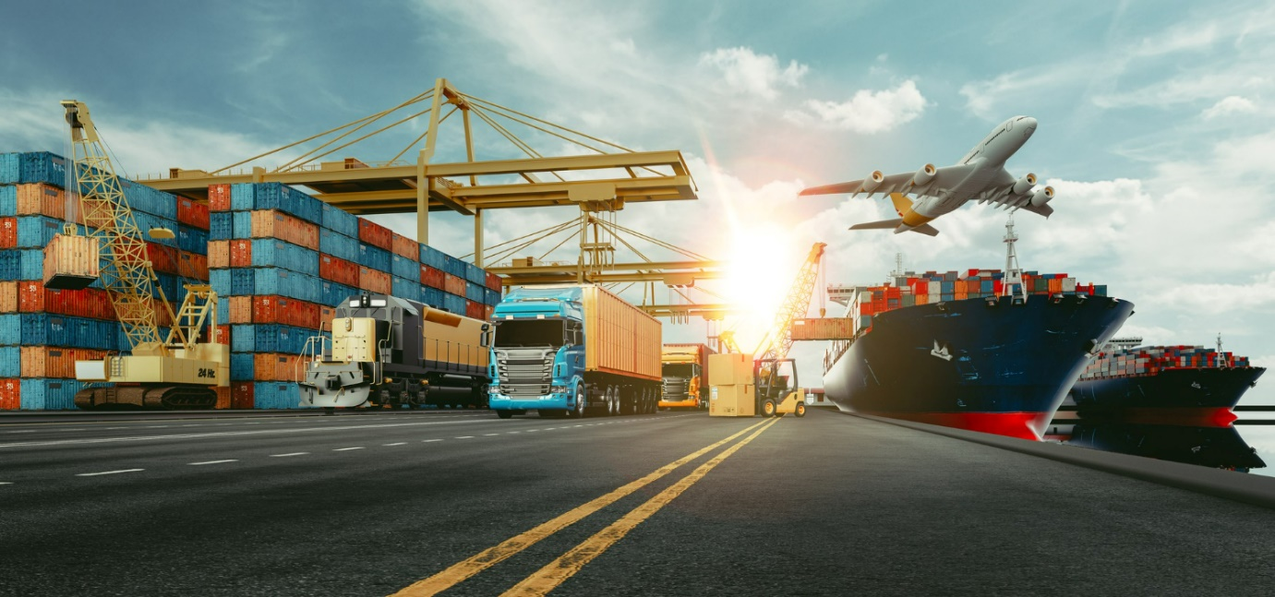
International Freight Forwarding Specialist

The Role of a Freight Forwarder Questions

Please refer to the following videos for your research.

Role of Freight Forwarders 1: https://www.youtube.com/watch?v=gHZecf_2JIM&ab_channel=LOGISTICSTOLOGICS

Role of Freight Forwarders 2:
https://www.youtube.com/watch?v=VdYycQE-6So&ab_channel=TepmareFrance

Please write an assignment of what is a role of a freight forwarder

Please include the companies involved in the process and what is their involvement in this?

Please explain what freight forwarding means to you?

Your customer calls and say they have 3000kg shipment they need to get to Sydney within in the next 10 weeks, what service would you best offer:

A-Ocean
B Road
C-Air
Please justify why you choose this answer

Your customer calls and say they have 75kg Dims 50x50x50cms, they need to get travel to Madrid within in the next week, what service would you best offer:

A-Ocean
B- Road
C-Air

Please justify why you choose this answer.

From the list below, what option best describes the role of a Freight Forwarder?

A company who wants to airfreight hazardous cargo
A provider to produce documentation for exports and imports
A company that organises shipments to get goods from the manufacturer to a destination point
A manufacturer of goods
A Consignee
A Shipper

A large company has a new UK launch coming up. Which of the following options would be the mode of transport you would recommend due to urgency and value of the goods?

Air Freight Consolidation service to reduce transit times but offering competitive rates
Ocean Freight service to keep prices at a competitive level
Rail service to ensure a low carbon footprint is offered
Sea/Air would offer lower costs overall and reasonable transit times

You are contacted by a customer who would like you to advise them of various modes of transport available to them. What would be the first three questions you would ask to progress with further options for them?

1) The urgency & destination? (2) Required delivery date, incoterms, type and dimensions of cargo? (3) Any hazard ?
(1) Are the goods ready? (2) Do you have Commercial Invoices? (3) The required routings for the cargo?
(1) What mode of transport is required? (2) What quote do you need? (3) Will the cargo fit into a container?
(1) When are the goods ready to go? (2) What documentation is needed? (3) Are the goods packed?

What are the advantages and disadvantages of Road, Rail, Air and Ocean?
Please refer to these websites and research them and submit your answers in the grid below:

https://accountlearning.com/sea-air-transports-advantages-disadvantages/

Rail: https://www.yourarticlelibrary.com/geography/transportation/advantages-and-disadvantages-of-railway-transport/42134

Mode | Advantages | Disadvantages
Air

Ocean

Road

Rail

Please upload to Learning Assistant for your ADC to review and provide feedback.

On your CPD Log please write up what you learnt through the research and what more you need to learn.

