
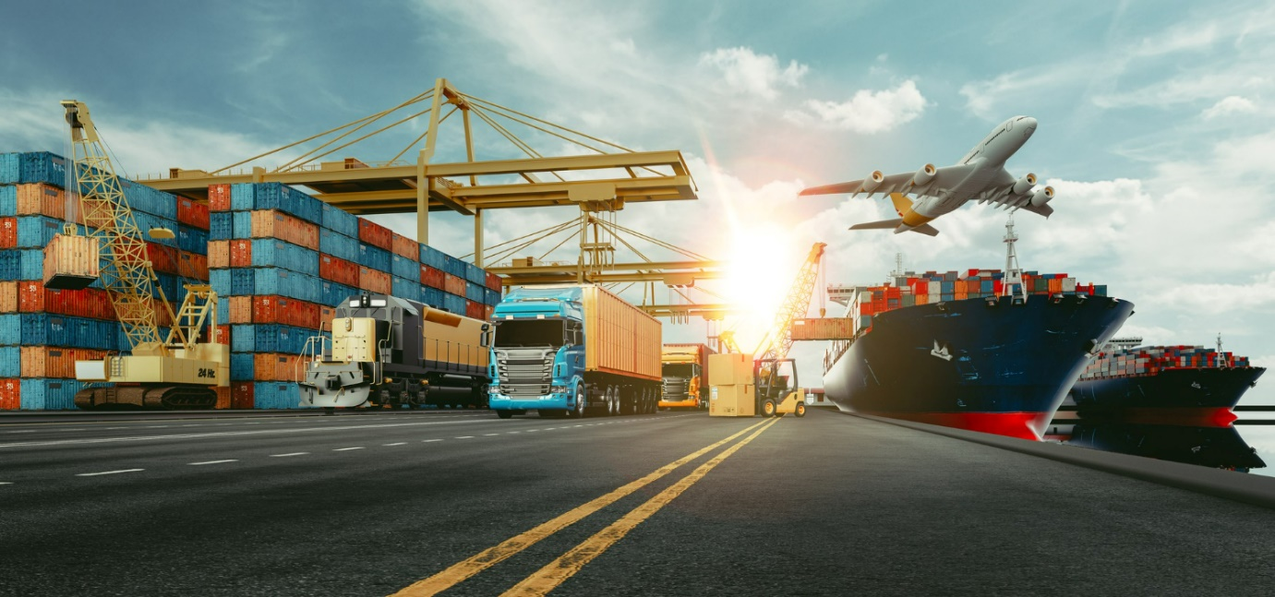
International Freight Forwarding Specialist

Regulatory Bodies in IFFS Questions

Regulatory Bodies in Freight Forwarding, the function and structure of the industry- Professional Discussion at EPA

If you have read the resource which have all the answers for these awarding bodies, please write a detailed explanation in your own words of the role for each of these?
Remember at EPA this will be a discussion.

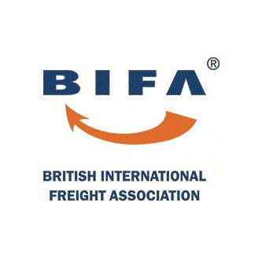

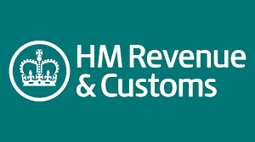

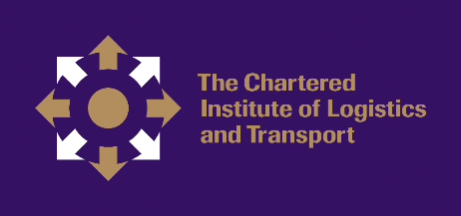


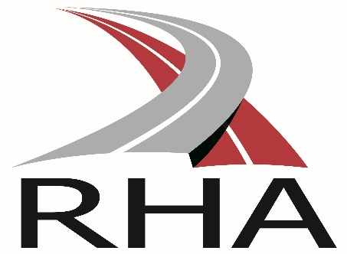
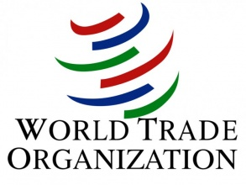



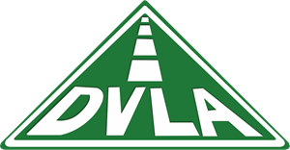


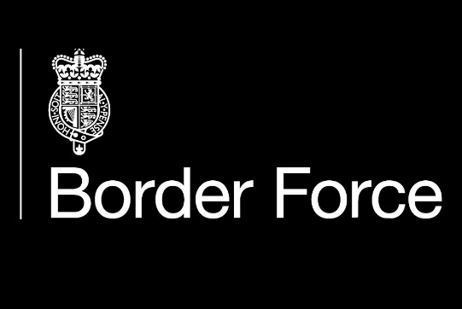

What is a bonded warehouse?

What are the benefits of this?

What charges does it alleviate?

What is an ERTS ?

What is the benefit it of this?

What charges does it alleviate?

The Role of each company involved in the process.

Depending on the pathway you are completing the roles will differ.

Example: Exporter-Is the shipper who send the goods and contacts the agent.

Importer

Agent

Ports

Customs

Handling Agent

Hauliers

Airline

Please provide details of any other company involved in your company and what is their role?

