
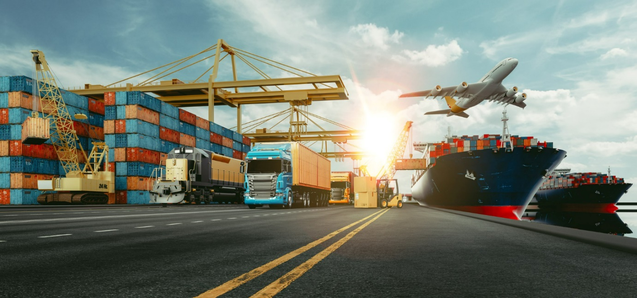
International Freight Forwarding Specialist

World Geography, Time Zones and

Political Boundary Questions

Please use this website research for all IATA codes, also has maps on their which will help with the project.

Please use these resources to research your answer:
International Airport Codes, IATA 3-letter Codes for Airports - Nations Online Project

Political Boundaries – Please use the following resources to answer the questions below

Video: (34) 4.4 Defining Political Boundaries - YouTube
Website: https://www.nationalgeographic.org/encyclopedia/boundary/
Website: https://www.arcgis.com/apps/MapJournal/

Describe what a political boundary is and explain what different types there are.
Please look to include within your work country examples of where political boundaries are prevalent.

Describe what is a continent and how it is made up, please name some.

What different types of boundaries are there?

IATA Codes – Please use the website below to research air and port codes and answer the questions below.
Air: https://airportcodes.io/en/iata-codes/
Ports (port codes are slightly longer, normally pre-fixed by the country code):
https://www.freightos.com/freight-resources/seaport-code-name-finder/

Why are there 3 letter IATA codes for Airports?

Who implemented these?

Why are there 5 letter codes for Ports?

Who implemented them?

Time zones and international borders.
Please use this website to research your answers to the below questions:
https://www.timeanddate.com/time/time-zones.html

In your own words, describe what an actual time zone is, outline how international borders are made up and explain longitude and latitude lines.

Please research: International borders, what GMT is and how the 24hour clock works throughout the world?

Actual borders on a time zone map have been modified to what?

What countries do you deal with, what are the time differences and how do you manage contacting them with the time difference in mind?

Transit times between modes: Researching at least five world-wide countries and compare Air and Ocean transit times.

Access to ports please refer to website or attached handout:

https://www.marineinsight.com/life-at-sea/dangerous-ocean-waters-ships-should-be-afraid-of/

Outline why some ports maybe restrictive for access. Please see the attachment (access to ports to consider, Page 58) – Infrastructure and to consider climate of waters.

Which Airport is in North America?

Atlanta
Beijing
HKG
Taipei

You are asked by a client for a quote to CFR Kobe, please confirm in which country is this city located?

Japan
Korea
Taiwan
China

The destination of JFK is 5 hours behind in time difference. You need to contact your customer urgently, but it is 9am in the UK, what time would it be in JFK?

17:00
04:00
19:00
23:00

What is an EFTA country? Please list them:
Please use this website to help answer the question: https://www.efta.int/about-efta/the-efta-states

Who would you contact about the preferences and trade agreements?

Sanctions and Embargos
Please use this website to help answer the questions below: https://www.gov.uk/guidance/current-arms-embargoes-and-other-restrictions

Please explain what a sanction is.

What is an embargo?

Please provide examples of specific sanctions and embargo’s both country and commodity embargoes?

Upload to Learning Assistant for your coach to mark

Please update your CPD log on what you have learned and what further learning is required.

