
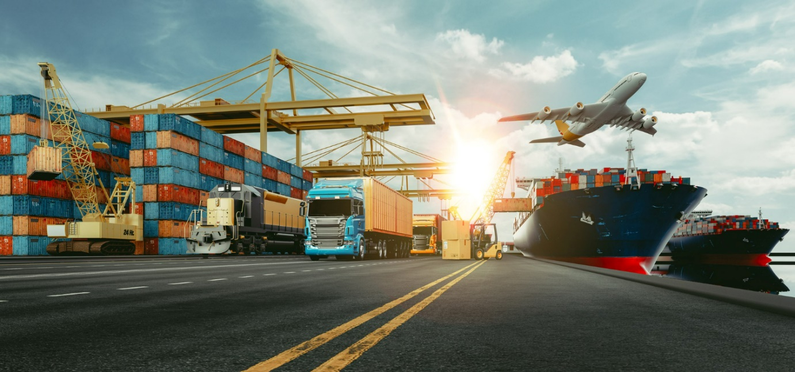
International Freight Forwarding Specialist

Consolidations - Professional Discussion at EPA

Explain and describe the process of consolidations. Use the two YouTube videos below for your research.

What is Freight Consolidation:
https://www.youtube.com/watch?v=WFjsgSLQQXQ&ab_channel=TrinityLogistics

7 Inbound Freight Consolidation Best Practices to Reduce Costs:
https://www.youtube.com/watch?v=IyPDjYg-vB4&ab_channel=Cerasis%2CnowpartofGlobalTranz

Q1. Please describe what are consolidations and why are they used?

Q2. Please list the advantages and disadvantages of consolidations? Video to watch: https://www.youtube.com/watch?v=XckCZS14f38&ab_channel=InternationalForwardingAssociation

Advantages | Disadvantages

Q3. Does your company book consolidation space with airlines/ports/trailers? if so, how?

Q4. What documentation is used?
Website to use: https://www.gov.uk/guidance/freight-forwarding-moving-goods
Under heading-International trade documentation for freight forwarders.

Q5. How are consolidations packed and in which device for each mode:

Air:

Road:

Ocean:

Q6. What is cross trade, does your company use this method?
Website to use: https://www.wssl.co.uk/cross-trade-shipments/#:~:text=A%20cross%20trade%20shipment%20is,our%20client%20in%20the%20UK

Q7. What is a co-loader?
Website to use: https://howtoexportimport.com/What-is-co-loading-314.aspx

Q8. What type of consolidations are used in Road freight?
Website to use: https://www.freightcenter.com/tools/types-of-freight/

Q9. In road freight how are the consolidations managed geographically?

Q10. What are the differences between- less than truckload vs full truckload?
Website to use: https://www.mach1global.com/four-major-types-of-freight-transportation/

Upload to Learning Assistant for your coach to mark

Please update your CPD log on what you have learned and what further learning is required.

