
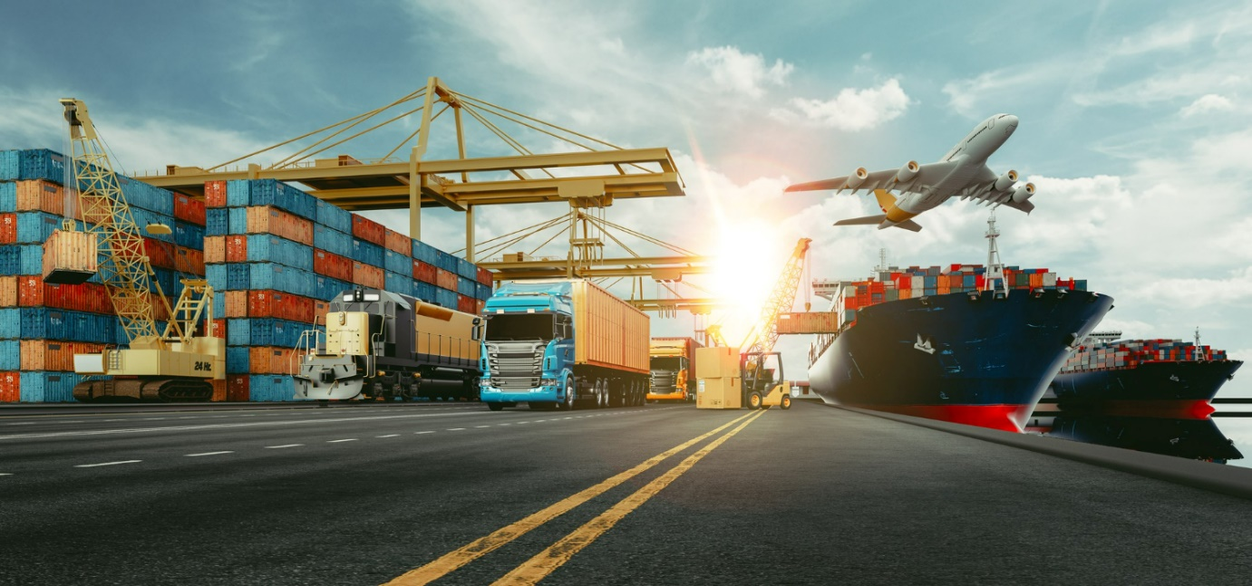
International Freight Forwarding Specialist

Hazardous Goods Questions

1. How many different classifications are there for Haz goods, please name them all in your assignment?

2. Why is the labelling of the freight important and what details should the label contain for Ocean, Road and Air?

3. What would be an indication that the goods contain hazardous products?

4. Why would class 5 oxidizers be restricted to Air freight only?

5. What are the IMDG volumes?

6. Can IATA DG note be used for an Ocean Freight Shipment?

7. Who provides a SDS sheet and explain what is the purpose of it?

8. If a vehicle has an accident on the M25, for goods hazardous goods, what can the safety data sheet be used for, if the emergency services arrive?

MSDS links- https://img.yumpu.com/8967223/1/358x507/material-safety-data-sheet-nutech-paint.jpg?quality=80

https://www.youtube.com/watch?v=uv3kx-k9rxQ

9. Define what is limited quantity?

10. Define what is meant by Expected quantity?

Upload to Learning Assistant for your coach to mark

Please update your CPD log on what you have learned and what further learning is required.

