
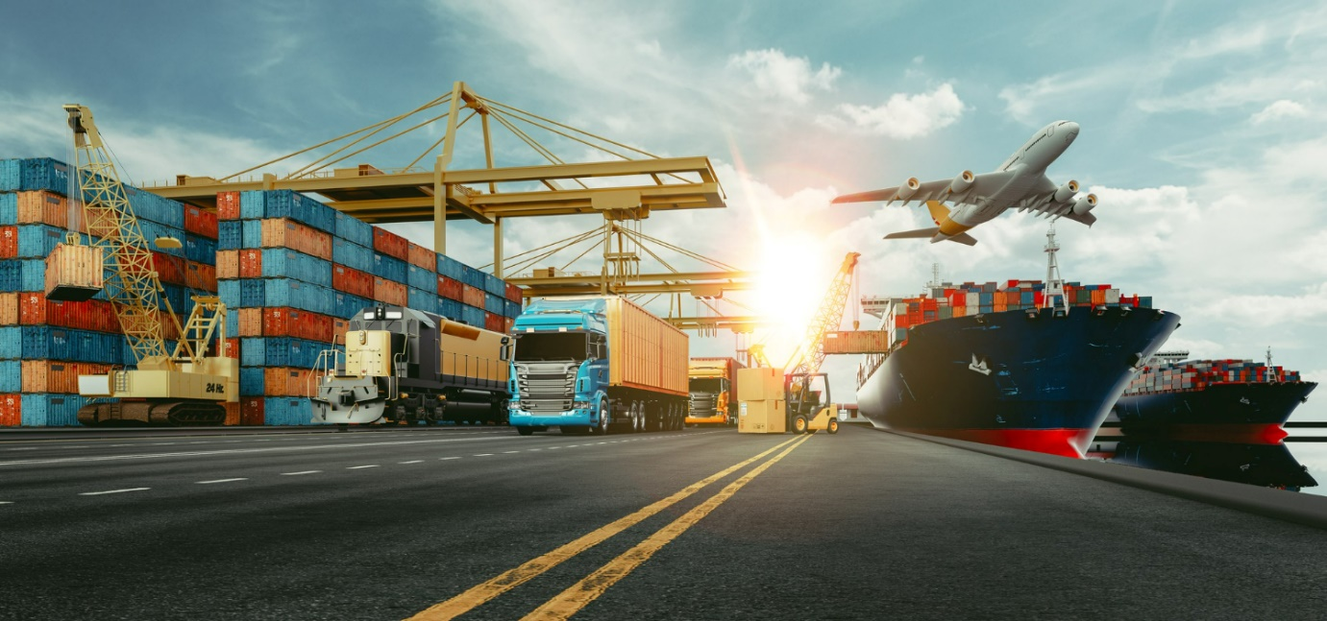
International Freight Forwarding Specialist

Letter Of Credit Questions

Please use the website and YouTube video below to research your answers.

What is a letter of credit, how it works and who needs it: https://www.shippingandfreightresource.com/letter-of-credit/

Letter Of Credit YouTube video: https://www.youtube.com/watch?v=cJa1U4FmYIM&ab_channel=InternationalTradeAdministration

Q1. What is a Letter of Credit?

Q2. What is the letter of Credit used for?

Q3. Who agrees the letter of credit?

Q4. Who is the letter of credit kept by?

Q5. Who issues the letter of credit?

Q6. Please research the different types of letters, what are they?

Q7. Which type provides more security?

Q8. What are the advantages and disadvantages of a LOC?

Watch the following video to research your answer: https://www.youtube.com/watch?v=9bZwWuiw8hQ&ab_channel=TradeFinanceGlobal

Advantages | Disadvantages

Upload to Learning Assistant for your coach to mark

Please update your CPD log on what you have learned and what further learning is required.

