SWOT Activity:

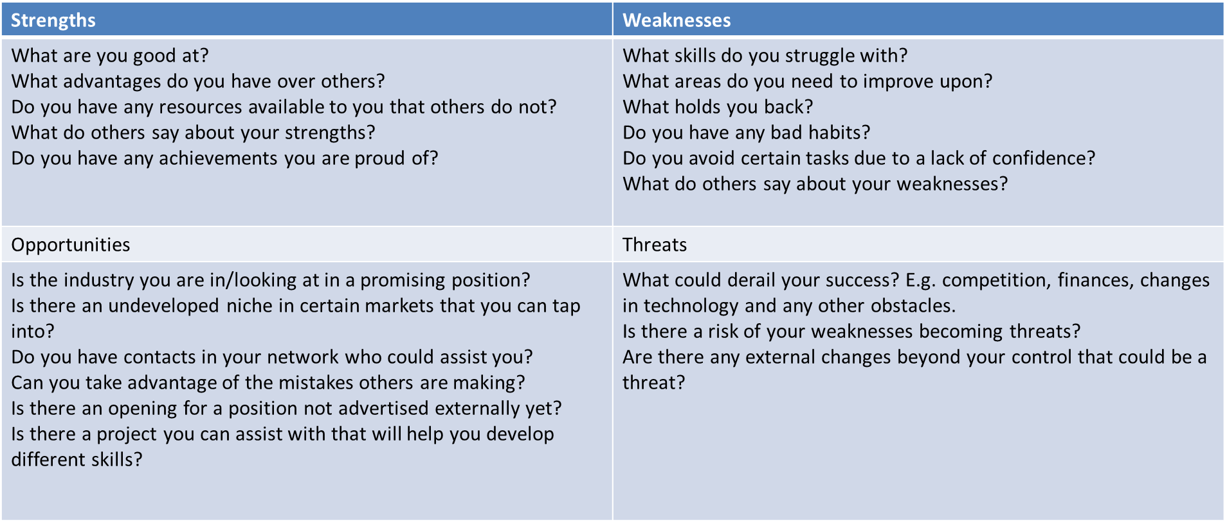

STEP ONE:
do a “SWOT” analysis on yourself, identifying their main Strengths, Weaknesses, Opportunities and Barriers that might stand in the way of strengthening weaknesses or seizing opportunities.
This first step is done individually, around 15 mins. Try to write down as much as possible.
Using the table above as guidance consider the questions.

Strengths | Weakness
Opportunities | Threats

